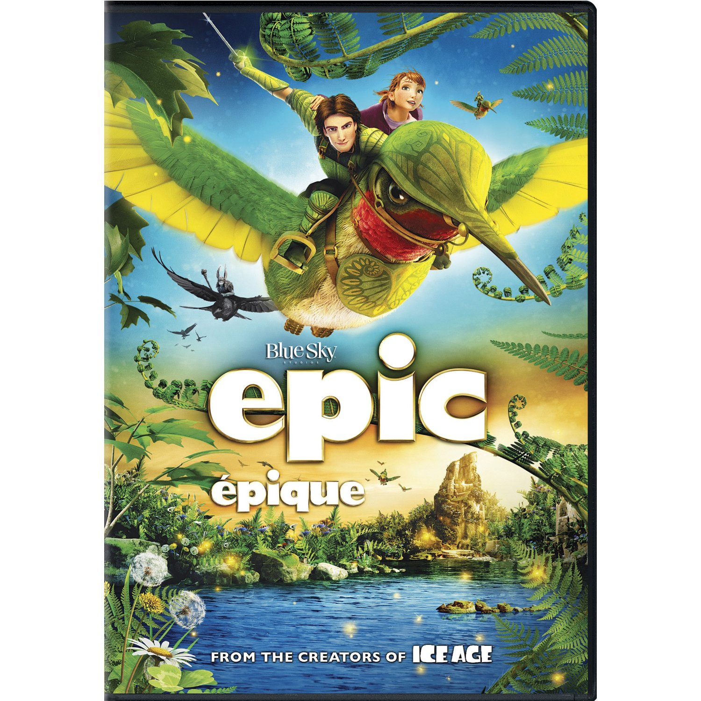
Hampton Park PAC will be hosting a
“BACK TO SCHOOL MOVIE NIGHT”
to welcome new families and to catch up with good friends
on
Friday September 13th, 2013 from 6:30pm- 8:30pm, School Gym
Please bring friends and family early so you can get a good seat on the floor for a FUN evening!
At the concession stand we will be selling: Pop, Juice, Water, Candy, Chips, and Popcorn for a $1.00 each. No Hot Food will be sold.
Parents, please remember to stay with your children throughout the whole movie and please do not bring food and drinks from home.
As always entrance to the movie is FREE!

